Communication Considerations for Grant Recipients
In recent years, the Commission’s communication approach has been centred on promoting awareness of the scheme itself to achieve sufficient quality applications.
We promote the scheme in regional media annually, highlighting the scheme opening date and once again announcing successful recipients.
Plans for coming years include an increased digital approach, with more photography and use of video.
The Commission encourages grant recipients to communicate about their projects early and often. If you are planning proactive regional PR and are interested in collaboration, depending on the circumstances, the Commission may be able to offer some support. We are always looking for new ways to promote the grant scheme further to reach harder-to-reach groups and welcome your engagement.

Your Contractual obligations
Beneficiaries of the IHREC Grants Scheme have the obligation to explicitly acknowledge that their action has received support. This must be done, if possible and unless the Commission requests otherwise, in all communication, dissemination and Intellectual Property Rights activities as well as on all major results funded by the grant.

How to credit the Commission
If you are producing any reports, flyers, posters, advertisements, social media, etc., in association with your project you must state that you have received IHREC funding.
This can be done by using the appropriate logo, acknowledgement or hashtags.

Logo
The logo to be used by grant recipients is shown below – it is not the regular commission logo.
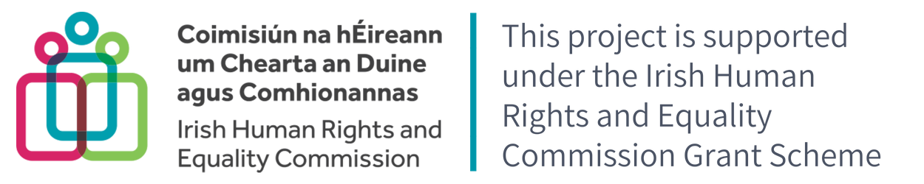

It will be sent directly to you, but can also be downloaded from the Grants page on the IHREC website.
Use of the IHREC grants logo shall only be used in direct connection with the grant funded project. Where the IHREC grants logo is proposed for use on publications or promotional material final approval of logo use should be sought through the Commission Communications team.

Placement
Logo placement should not be placed to imply or suggest unintended endorsement of views/ objectives and activities of the user of the logo by the Irish Human Rights and Equality Commission. The logo must be visible in its entirety and placed on a background which does not compromise its integrity. The logo is unalterable and inseparable. Modifying the logo in any way is prohibited.
The IHREC logo provided and reference to funding must be displayed in a way that is easily visible for the public and with sufficient prominence (taking also into account the nature of the activity or object).

Acknowledgement
The following acknowledgement must be placed in the inside cover of all publications produced in association with your project.
This project has received funding from the Irish Human Rights and Equality Grants Scheme as part of the Commission's statutory power to provide grants to promote human rights and equality under the Irish Human Rights and Equality Commission Act 2014. The views expressed in this publication are those of the authors and do not necessarily represent those of the Irish Human Rights and Equality Commission.
Example of Logo and acknowledgement placement on a publication
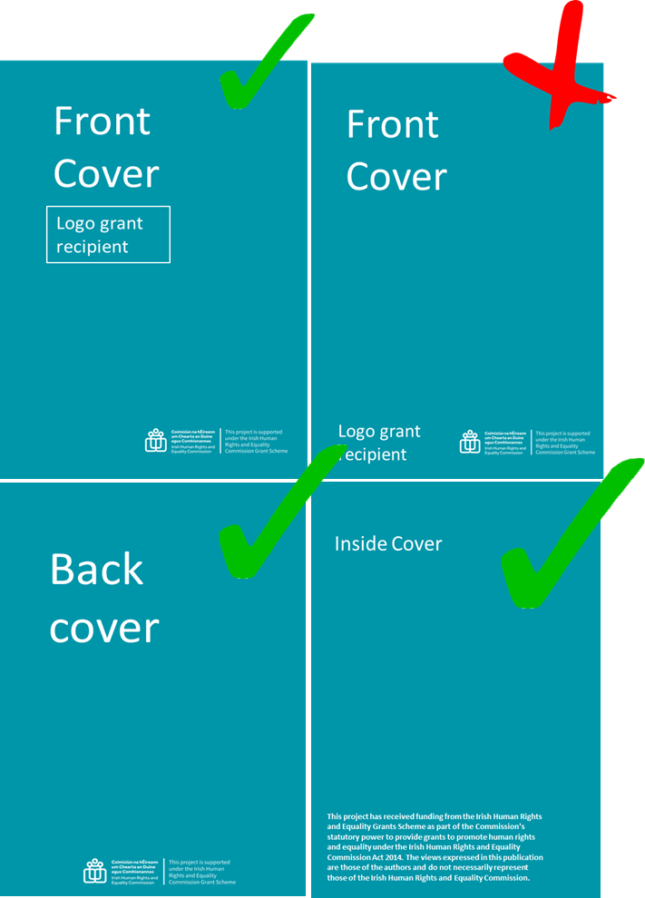
X: layout looks
like a joint
publication

Social Media
Social Media can be very beneficial for communicating your work and somewhere where we can very easily assist to amplify and boost your outputs. We have a number of social media platforms, but the main ones we use are Twitter, LinkedIn and Instagram. Please follow us and tag us in your posts.

Commission Social Media Handles
Twitter: @_ihrec
Instagram: @irishhumanrightsequality
LinkedIn: https://ie.linkedin.com/company/irish-human-rights-and-equality-commission

Hashtags
Where possible, the hashtag #IHRECSupported should be used in all social media posts about your project. This allows us to keep track of grant outputs, help amplify your posts and is also a way for you to see the progress of other projects.

Contact points for Grant Communications:
Linda Coyne – Communications T: +353 1 8589601 E: linda.coyne@ihrec.ie
Brian Dawson - Communications Manager T: +353 1 8589601 - E: Brian.Dawson@ihrec.ie

