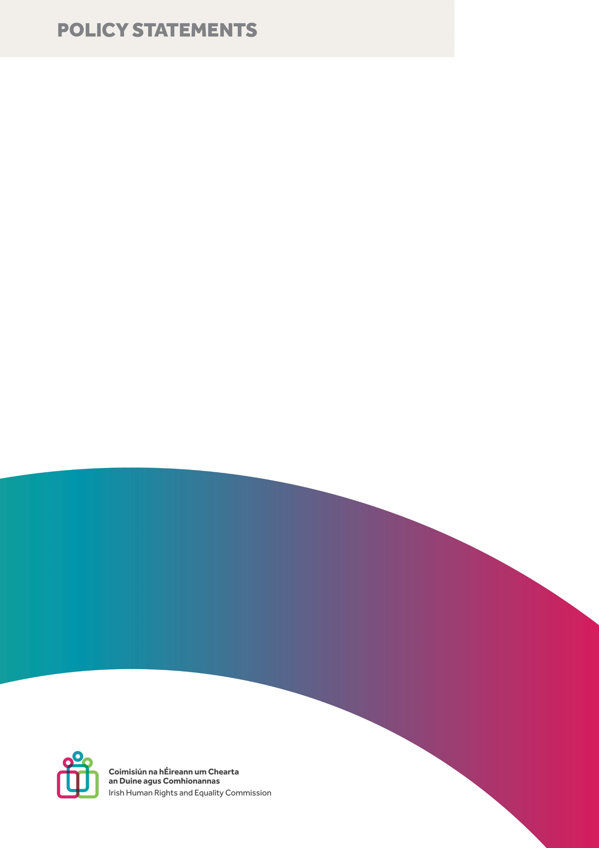
Policy Statement on the Index-Linking of Welfare Payments (Welfare Indexation)
Irish Human Rights and Equality Commission
February 2023

Published by the Irish Human Rights and Equality Commission.
Copyright © Irish Human Rights and Equality Commission 2023
The Irish Human Rights and Equality Commission was established under statute on 1 November 2014 to protect and promote human rights and equality in Ireland, to promote a culture of respect for human rights, equality and intercultural understanding, to promote understanding and awareness of the importance of human rights and equality, and to work towards the elimination of human rights abuses and discrimination.

Contents
Recommendations 1
Introduction 3
Welfare Indexation 4
The Policy Context 7
International standards 9
Key Elements of Welfare Indexation 12
Cost to the Exchequer 12
Governance, Oversight, and Monitoring 13
Design Considerations 14
Support and Incentives to Work 16
Evidence and Data 17
Conclusion 19

Recommendations

Cost to the Exchequer
The Commission recommends that the Government adopts Welfare Indexation across social welfare policy development and reform, as a matter of priority.
The Commission recommends that there is a greater emphasis placed on ensuring the adequacy of social welfare measures in future budgets.

Governance, Oversight, and Monitoring
The Commission recommends the establishment of an appropriately funded independent body - an Indexation Commission, staffed by a relevant mix of experts from public and civil society organisations - to consider, calculate, recommend, and monitor and review indexation measures.
Further, the Commission recommends that the mandate of the independent body should address the recommendations in this Policy Statement.

Design Considerations
The Commission recommends that welfare supports are indexed to wages, and that wage indexation is the most appropriate baseline for policymakers to work from.
The Commission recommends that an independent Indexation Commission should be tasked with assessing and recommending an appropriate benchmark percentage.
The Commission recommends that an independent, Indexation Commission should be tasked with assessing and recommending an appropriate reference point for indexation.

Support and Incentives to Work
The Commission recommends that qualifying thresholds for supports be adjusted in tandem with indexed welfare payments in order to ensure that recipients are not disqualified from supports they rely on.
The Commission recommends that supports are tapered as people move into employment in order to avoid cliff-edge effects and minimise disincentives to work.

Evidence and Data
The Commission recommends that the State addresses gaps in evidence and administrative data by investing to ensure timely, high-quality and accurate data to inform the work of the Indexation Commission.
The Commission recommends that the State prioritises research across Government Departments on the fiscal and distributional impact of policy changes on structurally vulnerable groups.

Conclusion
The Commission calls on the State to build Human Rights and Equality into the Taxation and Welfare system by introducing Welfare Indexation.

Introduction
The Irish Human Rights and Equality Commission (‘the Commission’) is Ireland’s ‘A’ Status National Human Rights Institution (‘NHRI’) and the National Equality Body, established under the Irish Human Rights and Equality Commission Act 2014. In our Strategy Statement 2022-2024, we have prioritised economic equality, focussing on improving protection of the poorest and those experiencing structural vulnerability, so that they are able to live with dignity and in economic security, whether working or in receipt of welfare or a pension, or both. Advancing economic equality involves challenging and changing policies and laws that exacerbate income and wealth inequalities, to build an inclusive Ireland, in which equality and human rights are respected. We have also prioritised futureproofing; focussing on responding to crises that threaten rights, providing equality and human rights assistance to those most affected, and identifying protective measures that forestall equality and human rights abuses.
Economic inequality impacts an entire society and its economy, and especially impacts structurally vulnerable groups. Economic equality is better for everyone; the more equally wealth is distributed, the better for society in general.
As Ireland recovers and rebuilds from the Covid-19 pandemic, we continue to experience the housing crisis and have now entered a cost of living crisis, exacerbating issues of economic inequality. Inflation reached a 12-year high in Ireland in early 2022 and inflationary pressures are set to continue. Sustained inflation generates a risk of increasing poverty and inequality, with structurally vulnerable groups known to experience inflation at a higher rate than the official measure.

Welfare Indexation
The indexation of welfare payments is of critical importance in the context of the continuing housing crisis, the cost of living crisis, rising inflation, and recessionary concerns.
The index-linking of welfare payments (welfare indexation) is the practice of increasing social welfare payments (including pensions), and/or tax credits and tax bands, in line with inflation.
Maintaining the adequacy of social supports is central to poverty reduction and important to ensuring an equitable society with a robust safety net. While Ireland is recorded as having one of the most progressive systems of taxation and social transfers across OECD countries, this system is, in part, a response to existing income inequalities. Analysis of Budget 2023 found direct tax and welfare measures to be regressive overall, meaning that lower income deciles lost out, proportionately.
The policy approach of index-linking welfare payments has the potential to uphold living standards for the most structurally vulnerable members of society, offsetting the effect of cost of living increases. It is supported by the Oireachtas Committee on Budgetary Oversight and is an evidence-based policy measure that would contribute to the Government policy ambition to make Ireland one of the most socially inclusive countries in the EU.
In this policy statement, we provide an overview of key elements of the discussion on welfare indexation. We endorse existing expert opinion, call for welfare indexation as a critical measure to advance economic equality, and recommend actions to support policy development and reform.
We identify five key elements that must be considered to determine the approach the Welfare Indexation in Ireland:
- Costs to the Exchequer;
- Governance, Oversight, and Monitoring;
- Design Considerations;
- Incentives to Work; and
- Evidence and Data.

The Policy Context
While the indexation of welfare payments is not currently a feature of Irish fiscal policy, it has been considered in the Irish policy context for over three decades. Recently, the Committee on Budgetary Oversight reported on its examination of:
“indexation of the social protection and taxation system and if it would provide greater budgetary scrutiny, ensure reduction in poverty levels and maintain pace with the cost of living.”
We endorse the expert recommendations therein, that indexation can provide greater certainty and planning for fixed and low-income households, and that additional spending on (universal) services should be done in tandem with a system of indexation. We endorse also the proposals made by the Commission on Taxation and Welfare in their final report “Foundations for the Future”, including the assertion that adequacy of social welfare rates is central to poverty reduction, and the recommendation that regular benchmarking exercises for working-age payments should be undertaken.
The final reports of the Committee on Budgetary Oversight and the Commission on Taxation and Welfare have been delivered in the context of a broader acknowledgment and discussion of welfare indexation across Government policy and strategy.
The Programme for Government “Our Shared Future” references “index-linking”, and commits to policy actions that protect the most vulnerable including:
- the index-linking of tax credits and bands;
- protecting core weekly social welfare rates;
- improving budgeting in relation to spending for social welfare; and
- recognising the importance of ancillary benefits and eligibility criteria to vulnerable groups.
The Roadmap for Social Inclusion 2020 – 2025 (the Roadmap) states the policy ambition to make Ireland one of the most socially inclusive countries in the EU, commits to protecting social welfare rates, equality (and gender) proofing changes made in relation to social welfare provisions, and recognises the importance of ancillary benefits. The Roadmap acknowledges the lack of explicit linkage between welfare rates and earnings and/or prices, and the inability of recipients of longer-term payments to plan or budget with confidence in this context. However, the discussion on the benchmarking of welfare payments in the Roadmap is limited to pension payments, and does not address Welfare Indexation as a standalone concern or as a feature of the broader social welfare system. We welcome other related developments regarding Universal Basic Income, including the work of the Low Pay Commission and the Basic Income for the Arts (BIA) pilot scheme.

International standards
Indexation is a feature of many OECD countries’ systems. Price indexation is in place in Belgium, Canada, France, Hungary, Iceland, Italy, Korea, Poland, Turkey and the USA. Wage indexation is in place in Germany, the Netherlands, Norway, Slovenia and Sweden. A combination of the two operates in Czech Republic, Estonia, Finland, Greece, Japan, Latvia, Luxembourg, Portugal, Slovak Republic and Switzerland. The ESRI has noted that the most common practice remains adjustment linked to prices.
Indexation regime | Countries
No automatic indexation, discretionary changes only | Austria
Price indexation | Belgium, Canada, France, Hungary, Iceland, Italy, Korea, Poland, Turkey, USA
Weighted average or other combination of price indexation and indexation with respect to wage or income changes | Czech Republic, Estonia, Finland, Greece, Japan, Latvia, Luxembourg, Portugal, Slovak Republic, Switzerland
Wage indexation | Germany,* Netherlands,* Norway, Slovenia, Sweden
Source: OECD (2017)
* The change is conditional on financial sustainability in this country. Japan: wage indexation to age 67, followed by price indexation thereafter. Norway: indexation to wage growth minus 0.75%. Sweden: wage growth minus 1.6%.
While there is no explicit reference to Welfare Indexation in existing human rights frameworks, related rights are afforded protection. The right to social security is highlighted in Article 9 of the International Covenant on Economic, Social and Cultural Rights, Article 5(e)(iv) of the Convention on the Elimination of All Forms of Racial Discrimination, Article 26 of the Convention on the Rights of the Child, and Article 28 of the Convention on the Rights of Persons with Disabilities. The European Social Charter also provides for the right to social security in Articles 8, 12, and 27, as well as outlining a general provision regarding protection against poverty in Article 3.
Welfare Indexation is relevant to United Nations Sustainable Development Goals (‘UNSDG’) one (No poverty), three (Good health and well-being), five (Gender Equality), and ten (Reduced Inequalities). The 2030 Agenda for Sustainable Development prioritises social protection systems, and recognises that eradicating poverty is:
“an indispensable requirement for sustainable development.”
The positive relationship between social security and economics is said to have informed the 2030 Agenda for Sustainable Development and its goals. More broadly, a central and transformational promise of the UNSDG mission is to “leave no one behind.” The UN stated that this promise represents the unequivocal commitment of all Member States to put in place effective measures to eradicate poverty and reduce inequalities and vulnerabilities.
Our work on budget proofing for human rights and equality set out key principles to realise economic and social rights that bear relevance to the issue of welfare indexation:
- states have a continuing obligation to take appropriate steps to realise rights as quickly and effectively as possible;
- appropriate steps include financial measures;
- when resources are severely constrained, vulnerable people can be protected by relatively low-cost targeted programmes; and
- budgetary process must include mechanisms to deliver transparency, accountability, and participation.
These principles serve as a foundation for the enhanced delivery of services to all members of Irish society, by placing equality and human rights at the core of how public bodies, including Government Departments, develop, deliver and implement policy in fulfilment of the Public Sector Equality and Human Rights Duty.

Key Elements of Welfare Indexation
Five key elements must be considered to determine an approach to Welfare Indexation in Ireland.
- Costs to the Exchequer;
- Governance, Oversight, and Monitoring ;
- Design Considerations;
- Incentives to Work; and
- Evidence and Data.

Cost to the Exchequer
We acknowledge that indexation represents a considerable fiscal cost to the Government. In its Tax Strategy Group paper for Budget 2023, the Department of Social Protection estimated the cost of indexing all weekly schemes (including pensions) to the Harmonised Index of Consumer Prices to be €1.4bn. Further, we acknowledge that automatic indexation would reduce policy flexibility to a certain extent, and that this constrains policy options in other areas to a degree. However, we note that the ad-hoc nature of the current system carries a considerable risk with regard to ensuring the adequacy of supports, particularly in the context of rising inflation.
We support additional investment in this area. Indexation of social welfare rates can provide certainty to households and people on fixed and low incomes. Additionally, indexation has benefits in relation to ensuring welfare income adequacy, the prevention of income inequality growth and the prevention of quality of life from worsening, particularly in the context of structurally vulnerable groups.
The Commission recommends that the Government adopts Welfare Indexation across social welfare policy development and reform, as a matter of priority.
The Commission recommends that there is a greater emphasis placed on ensuring the adequacy of social welfare measures in future budgets.

Governance, Oversight, and Monitoring
Independent bodies can significantly advance economic policy development and reform. The establishment of an independent body, such as a Commission, presents an opportunity for expert, independent, in-depth, and technical examination of welfare indexation.
The Committee on Budgetary Oversight has recommended the establishment of an independent body with a remit to assist the process of establishing the annual indexation rates, as well as the need for such a body to be appropriately funded and afforded full independence in its function. We note similar support from the Commission on Pensions, and the National Economic and Social Council. An independent body would be an important mechanism for ongoing monitoring and review of budgetary measures.
The governance of Welfare Indexation should operationalise the human rights principles of participation, transparency, and accountability.
The Commission recommends the establishment of an appropriately funded independent body - an Indexation Commission, staffed by a relevant mix of experts from public and civil society organisations - to consider, calculate, recommend, and monitor and review indexation measures.
Further, the Commission recommends that the mandate of the independent body should address the recommendations in this Policy Statement.

Design Considerations
The development of a system of Welfare Indexation comes with a number of design considerations.
A choice to be made is whether welfare supports should be indexed against prices or wages. Price indexation serves to offset the effect of cost of living increases on quality of life, poverty, and deprivation, but can result in welfare rates falling behind growth in wages. By contrast, wage indexation broadly prevents a worsening of inequality. Wage indexation is, however, more expensive to the exchequer. We understand that there is a trade-off between adequacy and cost when choosing to index welfare supports against prices or wages. We welcome the observation of the Committee of Budgetary Oversight that indexation linked to wage growth has the greatest impact on limiting the growth in income inequality.
The Commission recommends that welfare supports are indexed to wages, and that wage indexation is the most appropriate baseline for policymakers to work from.
A further choice to be made is what percentage of prices or wages welfare should be set at (the benchmark). In 2021, the Parliamentary Budget Office assessed using 27%, 27.5% and 30% of average earnings as potential benchmarks. It stated that Jobseeker’s Benefit rates have only reached this threshold between 2011 and 2014 when compared to 27% of average weekly earnings. It noted that, by 2022, based on an earnings growth forecast of 4.9%, Jobseeker’s Benefit would be 86% of 27% average earnings, 84% of 27.5% average earnings and 77% of 30% average earnings. We recognise that setting an adequate benchmark percentage represents a technical challenge, and consider that a suitably qualified and resourced independent body or Commission would be best placed to assess and recommend an appropriate benchmark percentage.
The Commission recommends that an independent Indexation Commission should be tasked with assessing and recommending an appropriate benchmark percentage.
A further choice to be made is whether the reference point for an index used should be prospective (forecasting) or retrospective (backcasting). We recognise that both forecasting and backcasting carry strengths and weaknesses. We note that backcasting has the potential to be designed as a lagging variable, relied upon on as an average of previous years. This approach would allow payments to decrease as well as increase, as necessary.
We accept that forecasting can be challenging, particularly in the context of unpredictable economies. We note that divergent views were expressed on the matter at the Committee on Budgetary Oversight. We welcome the Committee’s call for access to more robust and regular data in this context.
The Commission recommends that an independent, Indexation Commission should be tasked with assessing and recommending an appropriate reference point for indexation.

Support and Incentives to Work
We recognise that indexation carries with it a need to balance adequacy of welfare support and work incentives.
However, it is clear to us that any disincentive effect of indexation is more potent when enacted without adjustments to other parameters such as qualifying thresholds, and in-work benefits. There are a number of undesirable cliff-edges and step-effects in Ireland’s welfare system, which can result in individuals being left financially worse off as a result of taking up employment. Cliff-edges and step-effects describe the withdrawal of eligibility for social supports or an arising liability for certain taxes in response to a change in circumstances, usually as a result of increasing employment. These cliff-edges include the liability threshold for PRSI or USC; the availability of Domiciliary Care Allowance only until a child is aged 16; and the income thresholds for schemes such as Housing Assistance Payment (HAP) or the Working Family payment. For example, HAP income thresholds and maximum rent levels should be indexed, as HAP is available to those in full-time employment.
Childcare costs are a key barrier to employment for single parents, and one parent families face particularly high replacement rates. Young people (aged 18-24), migrants, lone parents, and those with low educational attainment all have significantly higher risk of low hourly wages and low weekly pay, which is also a disincentive. Barriers to work such as discrimination, availability of jobs and growth in the labour market, and having a disability also have an impact on uptake of employment. The participation rate of people with disabilities in the labour market in Ireland is also among the lowest in Europe. We also note that those who would be eligible for the Mobility Allowance scheme are still waiting for the successor scheme to be implemented. An indexation policy must ensure that the number of persons eligible for supports does not fall due to indexation or increasing employment.
The Commission recommends that qualifying thresholds for supports be adjusted in tandem with indexed welfare payments in order to ensure that recipients are not disqualified from supports they rely on.
The Commission recommends that supports are tapered as people move into employment in order to avoid cliff-edge effects and minimise disincentives to work.

Evidence and Data
There are serious shortcomings in the scale and scope of baseline research on equality, poverty, and more recently, on the impact of Covid-19. The national data infrastructure is not fit for purpose to develop, monitor and review anti-poverty measures or advance economic equality in line with its international obligations. In its final report, the Commission on Taxation and Welfare noted that, despite improvements in the quality and quantity of data on tax and welfare changes, data and analysis options remain limited, and called for a substantial programme of research in the area of taxation and welfare policy. The Committee on Budgetary Oversight also emphasised the need for access to more robust and regular data, while calling for increased cooperation and data sharing practices more broadly. It observed that the complexities around introducing a system of indexation highlights the need for access to quality data from Government Departments.
The Commission recommends that the State addresses gaps in evidence and administrative data by investing to ensure timely, high-quality and accurate data to inform the work of the Indexation Commission.
The Commission recommends that the State prioritises research across Government Departments on the fiscal and distributional impact of policy changes on structurally vulnerable groups.

Conclusion
We appreciate the body of work over decades and particularly in recent years that underpins Welfare Indexation. We welcome the policy momentum, particularly at this time of economic uncertainty.
We recognise the positive relationship between adequate social supports and economic progress. Adequate social welfare systems synergise with economic progress and, ultimately, prosperity. This relationship is embedded in the 2030 Agenda for Sustainable Development, and its guiding principle of “Leave no one behind.” Moreover, maintaining the adequacy of social welfare ensures a better society for all.
We accept that social supports in Ireland have generally kept pace with growth, despite the absence of an express policy of Welfare Indexation, and that Ireland’s taxation and welfare system has, to date, contributed to minimising income inequality, taking social transfers into account. However, relatively high income inequality persists in Ireland. As Ireland recovers and rebuilds from the Covid-19 pandemic, we continue to experience the housing crisis and have now entered a cost of living crisis. Existing budgetary efforts are insufficient in the context of these crises in tandem with inflationary pressures.
Notwithstanding, in the wake of the Covid-19 pandemic, Ireland has an opportunity to become a society that comprehensively supports people who are worst impacted by economic inequality. During the pandemic, the State’s response demonstrated that social supports can be deployed when necessary and that change can happen rapidly.
It is vital that the State acts now, by taking protective measures to prevent a further decline in living standards or a worsening of income inequality, to ensure the equality and human rights of those most impacted by economic inequality, and to futureproof the social welfare system by embedding indexation into the welfare policy process.
The Commission calls on the State to build Human Rights and Equality into the Taxation and Welfare system by introducing Welfare Indexation.

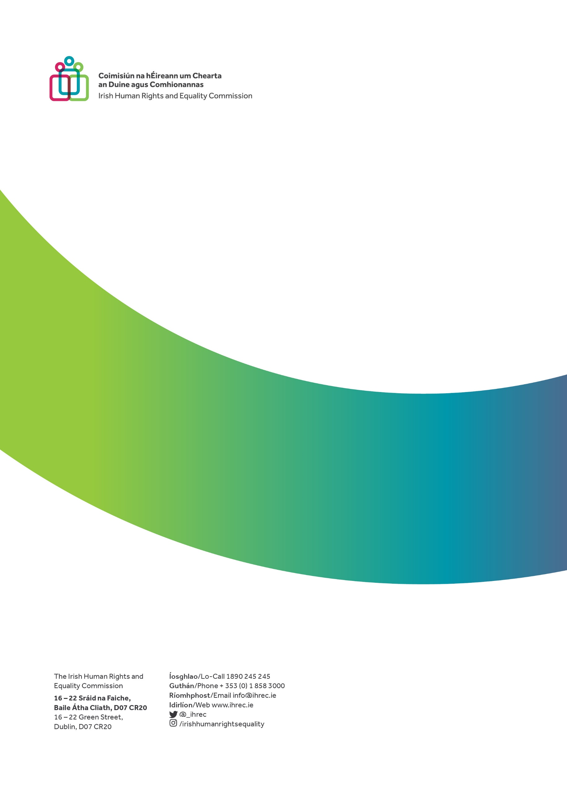

Irish Human Rights and Equality Commission, Strategy Statement 2022-2024 (December 2021), p. 3.
IHREC has previously set out positions in relation to a more transparent, inclusive and effective budgetary process (noting that such an approach is consistent with key principles of human rights), welcomed proposals to develop greater capacity to analyse distributional impacts of public services, and urged Government to publish a full Social Impact Assessment (SIA) of overall budgetary impacts with the budget. IHREC has also more recently commented on the importance of reducing economic equality, the properly protecting economic, social and cultural rights, and decent work. See: IHREC, Statement from the Irish Human Rights and Equality Commission on Budget 2017 (2016); IHREC, Comments on Ireland’s 19th National Report on the implementation of the European Social Charter (2022); IHREC, Monitoring decent work in Ireland (2021).
We define a structurally vulnerable group as one who is particularly vulnerable to violations of their rights due to political, economic, social and cultural structures. Instead of focusing on the personal characteristics of individuals and groups and viewing them as lacking agency, ‘structural vulnerability’ refers to the structures in place, which render certain sectors of the population particularly vulnerable to inequality and human rights abuses. Analysis of the Survey of Income and Living Conditions (SILC) data indicates that the proportion of people living in enforced deprivation increased from 13.8% in 2021 to 17.1% in 2022. The groups most likely to be experiencing enforced deprivation are persons; living in one-adult households with children under 18 (45.4%); unemployed (45.0%); unable to work due to long-standing health problems (42.7%); and living in rented or rent-free accommodation (34.1%). The CSO has previously reported on in-work poverty, noting that the risk of poverty rate for employed individuals was 4.4% in 2021, but would have been 11.7% without Covid-19 income supports, highlighting the importance of State intervention and support. We have previously called for an expansive and inclusive approach to measuring income adequacy and in-work poverty, considering a variety of quantitative indicators as well as qualitative data on the lived experience of structurally vulnerable groups. See: Central Statistics Office, Survey on Income and Living Conditions (SILC): Enforced Deprivation 2022, (November 2022).; Central Statistics Office, Survey on Income and Living Conditions (SILC) 2021, (May 2022). See: Irish Human Rights and Equality Commission, Submission to the Department of Social Protection’s public consultation on the Roadmap for Social Inclusion: Mid-Term Review, (October 2022), p.7.
We recognise that this is one of a number of measures to advance economic equality in combination with labour rights measures that realise the right to decent work, particularly in this context through adequate earnings and security and stability. See Irish Human Rights and Equality Commission, Strategy Statement 2022-2024 (December 2021), p. 11.; See McGinnity, F., Russell, H. Privalko, I. and Enright, S., Monitoring decent work in Ireland, ESRI Research Series, (June 2021).
In our submission to the Department of Social Protection’s public consultation on the Roadmap for Social Inclusion: Mid-Term Review, we called for additional supports for children, families, older people, workers and people with disabilities. We also recommended expanding opportunities for other cohorts, including migrants and ethnic minority communities including Travellers and Roma, and women. See: Irish Human Rights and Equality Commission, Submission to the Department of Social Protection’s public consultation on the Roadmap for Social Inclusion: Mid-Term Review, (October 2022), p.7.
See: Pickett, K., Wilkinson, R. The spirit level: Why equality is better for everyone. (2010); Baum, F. Wealth and health: the need for more strategic public health research, Journal of Epidemiology & Community Health 59.7 (2005): pp. 542-545.
See: Economic and Social Research Institute (ESRI) Despite significant headwinds, Irish economy set to perform in robust manner for remainder of 2022, however pace of growth set to moderate in 2023 as both macroeconomic uncertainty and inflationary pressures persist, (October 2022).
Parliamentary Budget Office, Inflation Issues for Ireland 2022, (2022), p.2. The ESRI forecast inflation of 8.1 per cent in 2022 and 6.8 per cent in 2023.
See Economic and Social Research Institute, Quarterly Economic Forecast Autumn 2022, (October, 2022).
Parliamentary Budget Office, Inflation Issues for Ireland 2022, (2022), p.2.
These groups included lower-income households, households that rent their home from a local authority, households renting privately, one-parent households, households where the dwelling is owned outright, and rural households. See Central Statistics Office, Estimated Inflation by Household Characteristics, (September 2022).
Economic and Social Research Institute, Assessing The Distributional Impact Of Budgetary Policy: The Role Of Benchmarks And Indexation, Callan et al, (2019), p.1.
See: Commission on Taxation and Welfare, Foundations for the Future: Report of the Commission on Taxation and Welfare, (2022).
OECD, Government at a Glance, (2021).
OECD, Economic Surveys Ireland (2018), p.38., Nevin Economic Research Institute (NERI), “Wages in Ireland are more unequally distributed than in any other high-income EU country”, (2021); The Irish Times, “Income inequality in Ireland: the devil is in the detail”, (2021).
Parliamentary Budget Office, An Introduction to the SWITCH Microsimulation models for Members, (2022).
See: Social Justice Ireland, Social Welfare Rates: Budget 2022 The case for benchmarking and indexation, (2021), p.5.; ESRI, Assessing The Distributional Impact Of Budgetary Policy: The Role Of Benchmarks And Indexation, (2019), p.3: “If benefit payment rates do not keep pace with price inflation, welfare recipients experience losses of real income.”.
The Committee recommended that indexation can provide greater certainty and planning for fixed and low-income households, that additional spending on (universal) services should be done in tandem with a system of indexation, and that the complexities around introducing a system of indexation highlights the need for access to quality data from Government Departments. See: Committee on Budgetary Oversight, Work Programme November 2021 - October 2022, (2021).; Select Committee for Budgetary Oversight, Report on Indexation of the Taxation and Social Protection System, (July 2022), p.6.
Government of Ireland Roadmap for Social Inclusion 2020 – 2025, (2020), p.15.
See Nevin Economic Research Institute, Indexation of the Taxation and Social Protection System, (2022); Committee for Budgetary Oversight, Report on Indexation of the Taxation and Social Protection System, (2022).
Irish Human Rights and Equality Commission, Strategy Statement 2022-2024 (December 2021), p. 11.
Welfare indexation is a feature of other OECD Member States’ policies. For example, a form of indexation of welfare payments is in place in Belgium, France, Hungary, Iceland, Italy, Poland, Germany, the Netherlands, Norway, Slovenia, Sweden, Turkey, Canada, Korea, and the USA. Parliamentary Budget Office, Social Welfare Rate Changes 2011 – 2022, (2021), p.7.
In 1986, the Commission on Social Welfare explored a range of approaches to arrive at an acceptable minimum income level for social welfare claimants. While Indexation was not adopted following the 1986 report, changes were recommended. In 2000, the Government’s Programme for Prosperity and Fairness provided for the establishment of a working group to examine the issues associated with the benchmarking and indexation of social welfare payments. The Social Welfare Benchmarking and Indexation Working Group delivered a report in 2001, finding that “the uncertainty associated with the medium to long-term wellbeing of the economy requires that the Government should not be tied into a fixed position in a critical area of public expenditure.” Again, a system of indexation did not follow. In Budget 2007, the Government index linked social welfare payments as a once-off adjustment to the welfare system. In 2016, the Minister for Social Protection expressed support for the indexation of social welfare payments, but a policy of indexing adjustments to the rates of social supports in Ireland was not adopted. See: Symposium On The Report Of The Commission On Social Welfare, (1986), p.3 - p.6.; Government of Ireland, Programme for Prosperity and Fairness, (2000), p. 80; Final Report Of The Social Welfare Benchmarking And Indexation Group, (2001), p.81; Social Justice Ireland, Social Welfare Rates: Budget 2022: The case for benchmarking and indexation, (2021). p.3; RTE.ie. “Indexing of welfare payments favoured by Varadkar,”(2016).
The Committee met a number of times in early 2022 with a view to discussing the rationale for indexation, the creation of an indexation system, the operation of that system, and the impact of indexation on budgetary sustainability. The Committee met on: 26/01/2022, 02/02/2022, 09/02/2022, and 16/02/2022. See: Committee on Budgetary Oversight, Work Programme November 2021 - October 2022, (2021). We welcome the publication of the Committee’s final report in July 2022. The Committee expressed the opinions that indexation can provide greater certainty and planning for fixed and low-income households, that additional spending on (universal) services should be done in tandem with a system of indexation, and that the complexities around introducing a system of indexation highlights the need for access to quality data from Government Departments. See: Committee for Budgetary Oversight, Report on Indexation of the Taxation and Social Protection System (2022), pp. 6-7.
Attendees included the Nevin Economic Research Institute (NERI), Social Justice Ireland (SJI), the Economic and Social Research Institute (ESRI), the Director of the Institute for Fiscal Studies in the UK. Officials from the Department of Finance, the Department of Public Expenditure and Reform, and the Department of Social Protection also attended.
Commission on Taxation and Welfare, Foundations for the Future: Report of the Commission on Taxation and Welfare, (2022), p. xxv.
Government of Ireland “Our Shared Future”, (2020).
Government of Ireland “Our Shared Future”, (2020), p.23.
Government of Ireland “Our Shared Future”, (2020), p.23.
Government of Ireland “Our Shared Future”, (2020), p.74.
Government of Ireland “Our Shared Future”, (2020), p.25.
Government of Ireland “Our Shared Future”, (2020), p.74.
Government of Ireland Roadmap for Social Inclusion 2020 – 2025, (2020), P.8.
Department of Social Protection’s Statement of Strategy 2020-2023, p.20.; Government of Ireland Roadmap for Social Inclusion 2020 – 2025, (2020), p.15.
Government of Ireland Roadmap for Social Inclusion 2020 – 2025, (2020), p.39.
Government of Ireland Roadmap for Social Inclusion 2020 – 2025, (2020), p.39.
Department of Enterprise, Trade and Employment, Low Pay Commission Annual Report 2022, 2022; Department of Tourism, Culture, Arts, Gaeltacht, Sport and Media, Basic Income for the Arts Pilot Scheme, 2022; Redmond,P., McGuinness, S. and Ciprikis,K. A universal basic inform for Ireland: Lessons from the international literature Dublin: ESRI (December 2022).
See: Parliamentary Budget Office, Social Welfare Rate Changes 2011 – 2022, (2021), p.7.
Assessing The Distributional Impact Of Budgetary Policy: The Role Of Benchmarks And Indexation, ESRI, Callan et al, 2019, p.3.
See, United Nations, “The 2030 Agenda for Sustainable Development”, para 1.
Razavi, S., Making the Right to Social Security a Reality for All Workers. Ind. J. Labour Econ. 65, 269–294 (2022). https://doi.org/10.1007/s41027-022-00378-6, p.270.
United Nations General Assembly, Transforming our world: the 2030 Agenda for Sustainable Development, p.1.
United Nations, Leave No One Behind, (2022), para 1.
See, Irish Human Rights and Equality Commission, Budget proofing for human rights and equality, (2016).
See, Irish Human Rights and Equality Commission, Realising Rights: Key Principles, (2016).
Public Sector Equality and Human Rights Duty - IHREC - Irish Human Rights and Equality Commission
Economic Social and Research Institute, Assessing The Distributional Impact Of Budgetary Policy: The Role Of Benchmarks And Indexation, (2019), p.22.
Department of Social Protection, Budget 2023 Issues, (2022), p.15.
See, NERI “Priorities for Budget 2023”, (2022); ESRI, Assessing The Distributional Impact Of Budgetary Policy: The Role Of Benchmarks And Indexation, (2019), p.1.
Independent bodies have been convened to address economic issues and make recommendations. The Commission on Taxation and Welfare was established in April 2021 and published its final report in September 2022. See: Commission on Taxation and Welfare, Foundations for the Future: Report of the Commission on Taxation and Welfare, (2022). Established in 2015, the Low Pay Commission makes annual recommendations to the Minister for Enterprise, Trade and Employment. See: Low Pay Commission, Annual Report 2022, (2022).
Committee for Budgetary Oversight, Report on Indexation of the Taxation and Social Protection System, (2022), p. 34.
Commission on Pensions, Report of the Commission on Pensions: Executive Summary, (2021), p.18.; Select Committee for Budgetary Oversight, Report on Indexation of the Taxation and Social Protection System, (2022), p. 8.
National Economic and Social Council, The Future of the Irish Social Welfare System: Participation and Protection, (2020), p. 86.
See, United Nations Human Rights Office of the High Commissioner, About good governance (Accessed November 2022).
Price indexation would involve increasing welfare rates each year based on inflation, most likely the CPI increase in the most recent previous period. Wage growth indexation would take a similar approach, using wage growth in place of price inflation, e.g., using the CSO’s EHECS earnings index.” Parliamentary Budget Office, Social Welfare Rate Changes 2011 – 2022, (2021), p.7.
Committee for Budgetary Oversight, Report on Indexation of the Taxation and Social Protection System, (2022), p. 23.
Economic and Social Research Institute, Assessing The Distributional Impact Of Budgetary Policy: The Role Of Benchmarks And Indexation, (2019), pp.3, 22.
The trade-off between the two measures signals the potential for an approach to indexation that considers a range within which changes might be made each year – thereby preserving policy flexibility.
Committee for Budgetary Oversight, Report on Indexation of the Taxation and Social Protection System, (2022), p. 27.
Parliamentary Budget Office, Social Welfare Rate Changes 2011 – 2022, (2021).
Parliamentary Budget Office, Social Welfare Rate Changes 2011 – 2022, (2021), p.11.
The National Economic and Social Council advocated for an “independent indexation group” in 2020. See: National Economic and Social Council, The Future of the Irish Social Welfare System: Participation and Protection, (2020), p. 86.
Committee for Budgetary Oversight, Report on Indexation of the Taxation and Social Protection System, (2022), p. 29.
Committee for Budgetary Oversight, Report on Indexation of the Taxation and Social Protection System, (2022), p. 29.
Committee for Budgetary Oversight, Report on Indexation of the Taxation and Social Protection System, (2022), p. 31.
Replacement rates are used as an indicator of this balance. See: Parliamentary Budget Office, The Impact of Indexation on Jobseeker’s Replacement Rates: A 2022 Case Study Approach, (2022), p.1.
See: Parliamentary Budget Office, The Impact of Indexation on Jobseeker’s Replacement Rates: A 2022 Case Study Approach, (2022), p.3.
See: Citizens Information, Domicilary Care Allowance. (Accessed December 2022).
See: Commission on Taxation and Welfare, Foundations for the Future, (2022), p.254 – 255. A stark example of this disincentive effect is described by the Parliamentary Budget Office, which notes that couple households with one potential earner and children need to earn close to average weekly earnings (€44,955 annually) before the incentive to move into employment is strong. This threshold exists in a context where emergency supports deployed in response to Covid-19 such as the PUP and TWSS were described as key policy levers in alleviating the impact of the Covid-19 public health restrictions on households and enterprises, and their introduction was unprecedented in terms of the expenditure, scale, reach and format.
See: Parliamentary Budget Office, The Impact of Indexation on Jobseeker’s Replacement Rates: A 2022 Case Study Approach, (2022), p.2.
See: Parliamentary Budget Office, The Impact of Indexation on Jobseeker’s Replacement Rates: A 2022 Case Study Approach, (2022), p.2.
See: Parliamentary Budget Office, The Impact of Indexation on Jobseeker’s Replacement Rates: A 2022 Case Study Approach, (2022), p.1.
The situation of many migrant workers is characterised by low pay, insecure hours, irregular hours, discrimination, lack of progression, and regular exploitation. In addition, research demonstrates that migrant groups have higher levels of education, but some experience higher unemployment than people born in Ireland. See: Migrant Rights Centre Ireland, All Work and Low Pay: The Experience Of Migrants Working In Ireland, (2015); Economic and Social Research Institute, Origin and Integration: A Study Of Migrants in the 2016 Irish Census, (2020).
Irish Human Rights and Equality Commission, Monitoring Decent Work in Ireland, (2021), p. x.
Irish Human Rights and Equality Commission, Monitoring Decent Work in Ireland, (2021), pp. x-xi.
58% of surveyed people viewed extra income as the most helpful form of support, and that increasing the probability and opportunities for employment for persons with a disability would be important for securing extra income. See: Department of Social Protection and Indecon, The Cost of Disability in Ireland - Research Report, (2021), p.xvi, p.118.
See: Citizens Information, Mobility Allowance (Accessed December 2022), and Oireachtas.ie, Transport Support Scheme, 31 March 2021.
Examples include the National Childcare Scheme, Rent Supplement, HAP, and Medical and GP-Visit cards.
Irish Human Rights and Equality Commission, Submission to the Third Universal Periodic Review Cycle for Ireland, (2021), p.2.
Commission on Taxation and Welfare, Foundations for the Future: Report of the Commission on Taxation on Welfare, (2022), p.486.
Committee for Budgetary Oversight, Report on Indexation of the Taxation and Social Protection System, (2022), p. 7-8.
Committee for Budgetary Oversight, Report on Indexation of the Taxation and Social Protection System, (2022), p.7.
“Social exclusion, with its associated social ills such as unemployment, educational disadvantage, drug addiction, homelessness, and crime, is now widely understood to act as a constraint on economic development as well as being a waste of human potential.” See: Final Report Of The Social Welfare Benchmarking And Indexation Group, (2001), p.25.
United Nations, Leave No One Behind, (2022).
Organisation for Economic Cooperation and Development, Economic Surveys Ireland (2018), p.38, and NERI, “Wages in Ireland are more unequally distributed than in any other high-income EU country”, (2021).
See: Economic and Social Research Institute (ESRI) Despite significant headwinds, Irish economy set to perform in robust manner for remainder of 2022, however pace of growth set to moderate in 2023 as both macroeconomic uncertainty and inflationary pressures persist, (October 2022).

