GUIDE

Guide to Reporting under the International Covenant on Economic, Social and Cultural Rights
Irish Human Rights and Equality Commission June 2023

Published by the Irish Human Rights and Equality Commission. Copyright © Irish Human Rights and Equality Commission 2023
The Irish Human Rights and Equality Commission was established under statute on 1 November 2014 to protect and promote human rights and equality in Ireland, to promote a culture of respect for human rights, equality and intercultural understanding, to promote understanding and awareness of the importance of human rights and equality, and to work towards the elimination of human rights abuses and discrimination.

Introduction
This guide gives a brief introduction to the International Covenant on Economic, Social and Cultural Rights (ICESCR). As Ireland has signed up to this Covenant, the State is required to report regularly on how it is implementing ICECSR. The UN Committee on Economic, Social and Cultural Rights receives these reports and monitors the application of ICESCR at national level. The reporting process is explained below, as is the importance of civil society engagement to provide its perspective on the extent to which Ireland is meeting its international human rights obligations.

International Covenant on Economic, Social and Cultural Rights
The International Covenant on Economic, Social and Cultural Rights (ICESCR) was adopted in 1966 and entered into force in 1976. 171 countries have ratified the Covenant, including Ireland in 1989, which means that the State has committed to respecting, protecting and fulfilling economic, social and cultural rights.
The rights protected by the Covenant include:

- Labour rights (Arts 6-8)

- Social security (Art 9)

- Protection of children and the family (Art 10)

- Adequate standard of living (Art 11)

- Health (Art 12)

- Education (Arts 13-14)

- Culture (Art 15)

Principles contained in the Covenant include obligations on Ireland to ensure:

- Maximum use of resources (Art 2)

- Progressive realisation of rights (Art 2)

- Non-discrimination (Art 2)

- International cooperation (Art 2)

- Equal rights of women and men (Art 3)

Committee on Economic, Social and Cultural Rights
The Committee on Economic, Social and Cultural Rights (CESCR) is the United Nations Treaty Body which monitors the implementation of ICESCR. The Committee includes 18 international experts who are elected for a term of four years. States are required to submit regular reports to the Committee on measures adopted and progress made in protecting Covenant rights.
Under the Optional Protocol to the International Covenant on Economic, Social and Cultural Rights, the Committee receives and considers communications from individuals who believe their rights under the Covenant have been violated. Ireland has not ratified the Optional Protocol, meaning that the Committee cannot currently hear individual complaints against Ireland.
Other duties carried out by the Committee include inquiries, considering inter-state complaints, and publishing general comments.

Why report to the Committee on Economic, Social and Cultural Rights?
Civil society reporting to CESCR is a valuable way to achieve national and international impact. By highlighting rights infringements experienced by under-represented groups, civil society reports provide the Committee with a more complete picture of socio-economic rights in Ireland. This plays an important role in holding the State to account. Civil society reporting has been demonstrated to have a direct influence on the Concluding Observations of UN Committees. As Concluding Observations are given significant weight by States, engagement with UN Committees can advance ongoing policy and advocacy work, and create the pressure and support needed to progress issues at the national level.
While civil society engagement requires planning and the use of limited resources, organisations can use, build on and adapt existing research, policy and advocacy work for the CESCR reporting

process. Reporting can therefore be integrated into a broader strategy and work-plan to reduce the additional capacity required, while also enabling organisations to promote their work internationally. Effective engagement with CESCR’s reporting process provides an important opportunity to harness the power of the international human rights system to reinforce advocacy messages and affect change for the advancement of socio-economic rights.

International reporting procedure
Although a number of UN Treaty Bodies have adopted the simplified reporting procedure to streamline the process, CESCR has only adopted this procedure on a pilot basis. The Committee therefore uses the standard reporting procedure.
This consists of:

- Submission of the State report, which outlines measures taken to implement ICESCR and how effective these measures have been.
- Civil society and National Human Rights Institutions send materials to the Committee in advance of the Committee’s List of Issues. Submissions may be published online or kept confidential.
- The State report and any stakeholder inputs are considered by the Committee during a Pre-Sessional Working Group (PSWG). During the PSWG, the Committee adopts a List of Issues for the State under review, which sets out the main areas of concern in relation to the implementation of ICESCR. It publishes the List of Issues and sends it to the State in question, requesting further information.
- The State responds to the List of Issues, addressing the areas of concern highlighted by the Committee.
- Civil society and National Human Rights Institutions send parallel reports to the Committee (see guidelines below).
- The State review takes place in Geneva during one of the Committee’s scheduled sessions. The review will consist of a dialogue between the Committee and the State, usually taking place over three meetings (of three hours each).

- Following the State review, the Committee will prepare Concluding Observations, noting positive developments, areas of concern, suggestions and recommendations.

Ireland’s fourth periodic review under ICESCR
Ireland’s fourth periodic review began in February 2021, when Ireland submitted its State report to the Committee. CESCR considered the report during its Pre-Sessional Working Group in March 2022, and adopted its List of Issues at that meeting. Prior to the meeting, CESCR received submissions from Atheist Ireland, Disability Federation of Ireland, Inclusion Ireland, Independent Living Movement Ireland, Irish Penal Reform Trust, a coalition of Irish Traveller and Roma organisations, Irish Council for Civil Liberties, and the World Policy Analysis Center. IHREC also made a submission to inform CESCR’s List of Issues in December 2021.
The State submitted its Reply to the List of Issues in September 2023. The review will take place in Geneva on 15-16 February, during CESCR’s 75th session. Parallel reports may be submitted up to 12 January 2024.
Civil society may attend the review virtually or in person. CESCR will meet with civil society prior to the review for an informal briefing.

General guidelines for the preparation of parallel reports
CESCR welcomes specific, reliable and objective information from international, regional, national and local organisations. CESCR encourages comprehensive submissions prepared by coalitions (as opposed to thematic reports which are narrowly focused on specific rights), and recommends numbering paragraphs for ease of reference. CESCR invites submissions of no more than 10 pages from individual organisations and no more than 15 pages for coalition submissions.
CESCR’s List of Issues will be a key document in the preparation of parallel reports and should guide civil society reporting. However, CESCR does not focus strictly on the List of Issues during the review and will consider matters outside of these thematic areas if raised by civil society. In recent years, CESCR has developed a particular interest in business and human rights, climate change and Covid-19.

Submission details
Organisations should create an account on the OHCHR online CESCR submissions system. To create an account, organisational details must be registered on the system via an online form. The account will not be active until the CESCR Submissions System team administrator confirms your registration (you will be notified by email). The CESCR team are available to respond to any technical issues (cescr@ohchr.org).
Individual organisations can only register on the submissions system once. Once the account has been created and the registration has been confirmed, the organisation can log in to upload the report before the deadline.

Further resources
- 75th Session of the Committee on Economic, Social and Cultural Rights, Session page

- Committee on Economic, Social and Cultural Rights, Rules of procedure and working methods
- CESCR, List of issues in relation to the fourth periodic report of Ireland (2022)

- IHREC, Submission to the UN Committee on Economic, Social and Cultural Rights for the List of Issues on Ireland’s Fourth Periodic Report (2021)
- IHREC, Ireland and the International Covenant on Economic, Social and Cultural Rights (2015)
- FLAC, Parallel report in response to Ireland’s Third Report under the International Covenant on Economic, Social and Cultural Rights (2014)
- Contact details:

  - Secretariat: ohchr-cescr@un.org

  - Submissions system technical support: cescr@ohchr.org

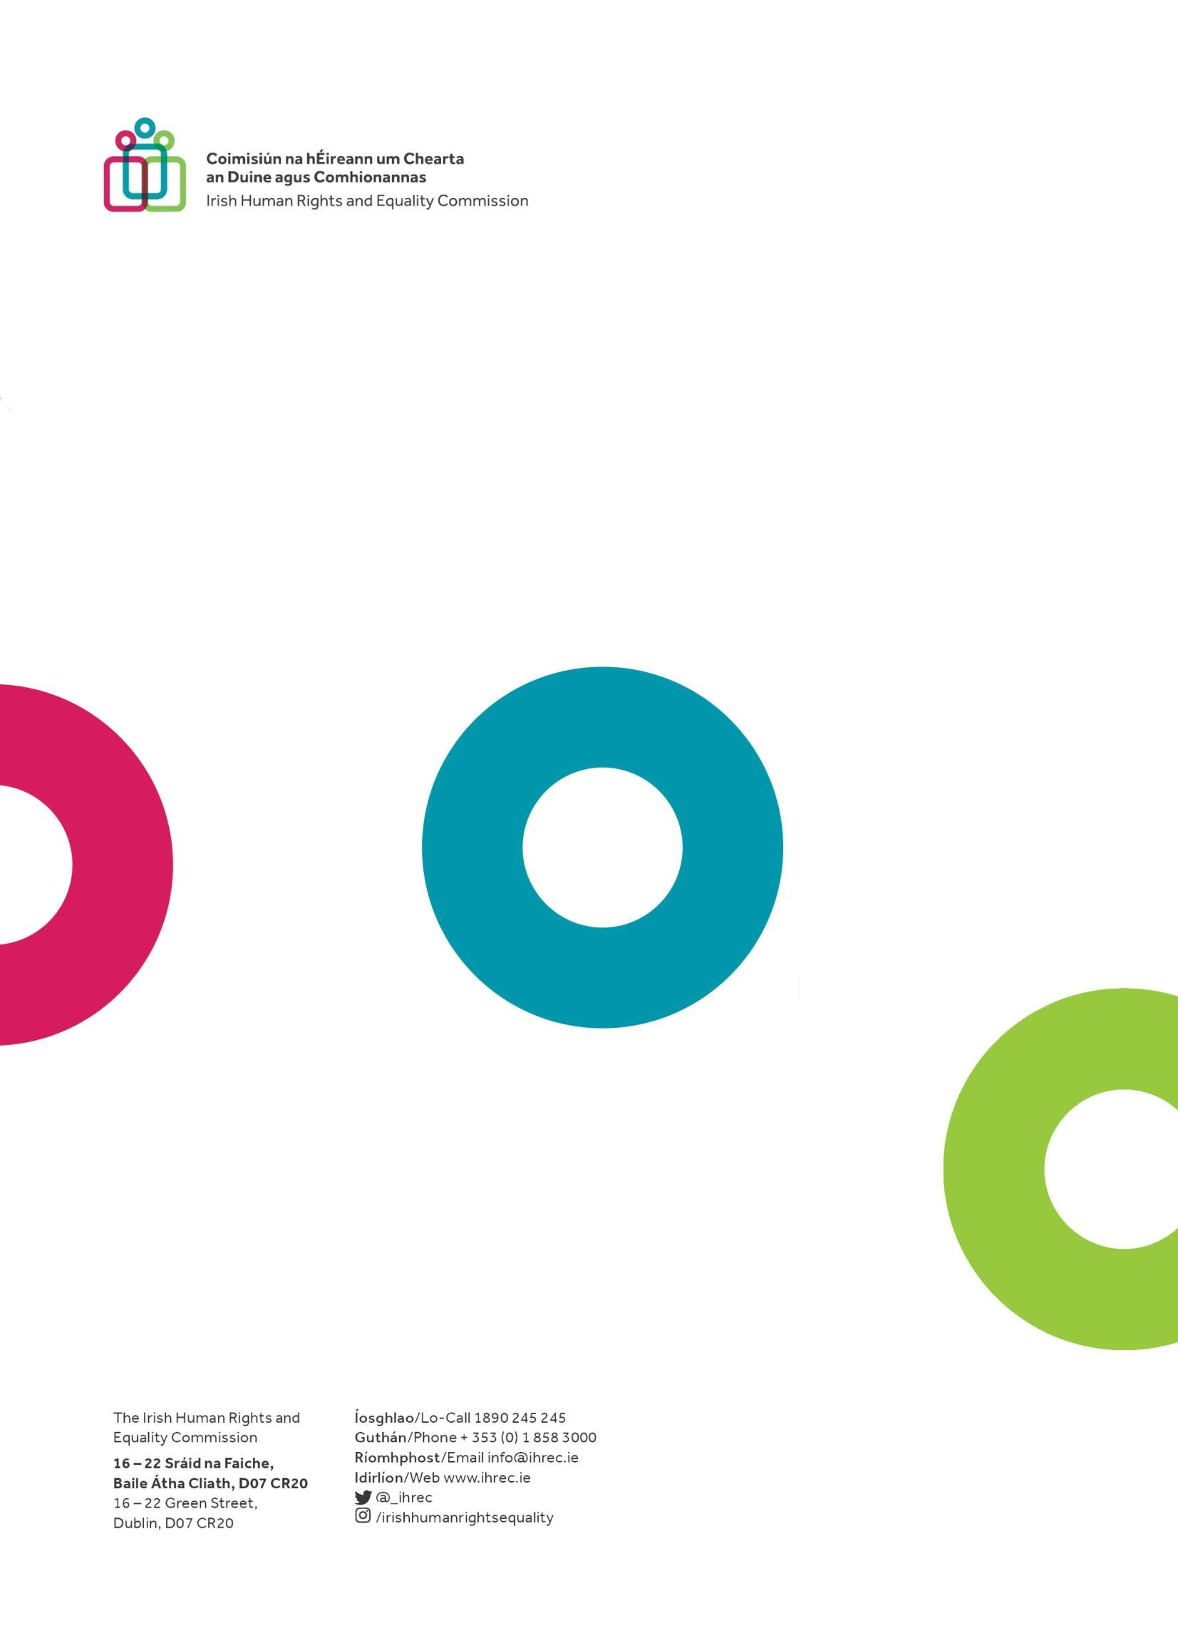

6

As all dates are subject to change, please consult the Session Page for the most up-to-date information.

