# Equality and Human Rights on the Island of Ireland after Brexit

# Equality and Human Rights on the Island of Ireland after Brexit

# Equality and Human Rights on the Island of Ireland after Brexit

# Equality and Human Rights on the Island of Ireland after Brexit

Copyright © Irish Human Rights and Equality Commission, Northern Ireland Human Rights Commission and Equality Commission for Northern Ireland 2023

ISBN: 978-1-913492-17-5

## Equality and Human Rights on the Island of Ireland after Brexit: Annual joint report of IHREC, ECNI and NIHRC on the implementation of Article 2 of the Windsor Framework. October 2022 – September 2023.

Irish Human Rights and Equality Commission

Northern Ireland Human Rights Commission

Equality Commission for Northern Ireland

December 2023

## Contents

Foreword 2

Report outline 4

Introduction 5

Three Commission activity October 2022 – September 2023 7

Research and Policy 7

Working Group meetings 13

Parliamentary engagement 15

Civil society engagement 17

Planned engagement with European Union stakeholders 19

Concluding comments 20

Appendix 1: About the Commissions 21

## Foreword

This is the second activity report on our three Commissions’ joint work to ensure the implementation of Article 2 of the Windsor Framework from an island of Ireland perspective. The report covers the work of our Commissions in this regard from October 2022 to September 2023.

In this period, we have built on the foundations we laid over recent years to continue working well with each other as three Commissions. We have also worked effectively in a joint capacity to develop research and policy recommendations on the central issues to be addressed, and engaged with key stakeholders in civil society and Parliament. All of these work streams are of vital importance as we seek to ensure the Article 2 commitment on equality and human rights in Northern Ireland is upheld, more than two years on from Article 2 becoming a binding piece of international law.

The anchor for addressing equality and human rights on an island of Ireland basis is, of course, the Belfast (Good Friday) Agreement. The Agreement instigated the establishment of our three Commissions, and set out a broad expectation of equivalence in rights protections in Ireland as in Northern Ireland.

This year, 2023, marked the 25-year anniversary of the Agreement, which rightfully brought commemorations and indeed celebrations to mark that historic event.

However, the anniversary also presented an opportunity to pause for thought and reflect on just how important it is that the Agreement remains at the centre of our island’s future. Foremost in this respect are the equality and human rights provisions that have been foundational to the progress made under the Agreement, and which now seem more important than ever given the significant and evolving risks to equality and human rights on the island of Ireland post-Brexit.

Alyson Kilpatrick SignatureGeraldine McGahey SignatureWith this in mind, our Commissions are more resolute than ever, including through our joint working, to discharge our mandates to promote and protect human rights and equality for everyone on the island of Ireland.

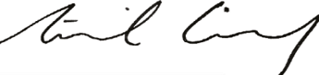

**Sinéad Gibney Geraldine McGahey Alyson Kilpatrick**

Chief Commissioner, Chief Commissioner, Chief Commissioner,

Irish Human Rights and Equality Commission for NI NI Human Rights Commission

Equality Commission

## Report outline

This report provides an overview of the joint work of the Irish Human Rights and Equality Commission (IHREC), Equality Commission for Northern Ireland (ECNI), and Northern Ireland Human Rights Commission (NIHRC) in relation to providing oversight of, and reporting on, rights and equalities issues falling within the scope of Article 2 of the Windsor Framework (formerly known as the Ireland/Northern Ireland Protocol) that have an island of Ireland dimension.

The report covers the period October 2022-September 2023.

## Introduction

The UK signed the UK-EU Withdrawal Agreement in January 2020 and the Protocol on Ireland/Northern Ireland (now referred to as the Windsor Framework), which is part of the treaty, took effect from 1 January 2021.[1]

Windsor Framework Article 2 states:

1. The United Kingdom shall ensure that no diminution of rights, safeguards or equality of opportunity, as set out in that part of the 1998 Agreement entitled Rights, Safeguards and Equality of Opportunity results from its withdrawal from the Union, including in the area of protection against discrimination, as enshrined in the provisions of Union law listed in Annex 1 to this Protocol, and shall implement this paragraph through dedicated mechanisms.
2. The United Kingdom shall continue to facilitate the related work of the institutions and bodies set up pursuant to the 1998 Agreement, including the Northern Ireland Human Rights Commission, the Equality Commission for Northern Ireland and the Joint Committee of representatives of the Human Rights Commissions of Northern Ireland and Ireland, in upholding human rights and equality standards.[2]

In Article 2, the UK Government commits to ensuring that certain rights, safeguards and equality of opportunity protections are not diminished as a result of the UK leaving the EU. Therefore, to fall within scope of Article 2, the human right or equality protection being relied on must be covered by the relevant chapter of the Belfast (Good Friday) Agreement and have been underpinned by EU law including EU treaties, directives and regulations, in place on or before 31 December 2020.[3]

In addition, Article 2 entails a commitment that NI equality law will dynamically align or ‘keep pace’ with any enhancements made by the EU to rights under the six main Equality Directives listed in Annex 1 to the Windsor Framework.

The ECNI and the NIHRC are mandated in accordance with Article 2 to act as dedicated mechanisms to oversee the UK Government’s commitment on rights and equality in Northern Ireland after EU withdrawal. In addition, the NIHRC and ECNI are working together with IHREC to provide oversight of, and reporting on, rights and equalities issues falling within the scope of the Article 2 commitment that have an island of Ireland dimension.

In March 2021, the three Commissions agreed a Memorandum of Understanding that sets out working arrangements for fulfilling this mandate.[4] In line with this, IHREC, ECNI and NIHRC publish an annual joint report on the implementation of Article 2. The first such report, covering the period January 2021-September 2022, was published in November 2022.

This is the second such annual joint report by the three Commissions.

## Three Commission activity October 2022 – September 2023

### Research and Policy

#### European Union Developments in Equality and Human Rights: The Impact of Brexit on the Divergence of Rights and Best Practice on the Island of Ireland

The Belfast (Good Friday) Agreement requires “at least an equivalent level of protection of human rights” in Ireland as in Northern Ireland.[5] The Commissions are of the view that long-term North-South equivalence of rights is important to ensure there is no diminution of rights in NI and that human rights and equality protections are subject to continual improvement.[6]

Prior to Brexit, EU law had facilitated the alignment of many laws on rights and equality between Ireland and Northern Ireland. Whilst the Windsor Framework requires that NI equality law keeps pace with any EU changes to the Annex 1 equality directives which enhance protections,[7] there is the potential for equality and human rights on the island of Ireland to diverge after the end of the Brexit transition period; with NI falling increasingly behind rights in Ireland.

In order to track this divergence, the ECNI, on behalf of the NIHRC and Irish Human Rights and Equality Commission, published jointly commissioned research in 2023, undertaken by a team of expert researchers, on the impact of Brexit on the divergence of rights and best practice on the island of Ireland.[8]

The research found that there are already a number of proposed EU laws, and EU laws which came into effect after 31 December 2020, that have the potential to strengthen equality and human rights. Once in force, such EU laws will need to be implemented in law in Ireland, but Northern Ireland law will not be required to keep pace with them as a result of the Windsor Framework. Examples of EU legislative developments that could lead to divergence of rights include EU law relating to women; disabled people and older people, such as, the Work-life Balance Directive,[9] and the European Accessibility Act.[10]

The research also found that Northern Ireland could fall behind in terms of policy developments in the area of equality and human rights, as progressive or good practice policy initiatives are developed and actioned in the EU, such as the LGBTQI Equality Strategy.[11]

In addition, the research identified a number of significant Court of Justice of the European Union case law developments since 31 December 2020 relating to the interpretation of the Annex 1 equality directives, which continue to have implications for how particular legal rules operate in Northern Ireland.[12] This includes Court of Justice of the European Union judgments in cases concerning disability discrimination law,[13] religious freedom / manifestation of religious symbols at work,[14] and effective judicial protections.[15]

Prior to the withdrawal of the UK from the EU, there were already gaps in protection against discrimination between Northern Ireland and both Ireland and Great Britain,[16] for example, in the areas of gender pay gap reporting, single equality legislation and age discrimination in access to goods, facilities and services.[17]

The IHREC, ECNI, and NIHRC have, as a result of the findings of the research, developed a number of key policy recommendations.[18]

Included amongst these were two recommendations made jointly by all three Commissions:

* **that North-South equivalence of rights and protections is ensured, by Northern Ireland law keeping pace with changes to EU equality and human rights law that strengthen protections. This should include rights introduced as a result of EU laws that do not amend or replace the Windsor Framework Annex 1 directives.**
* **that the Irish Government, Northern Ireland Executive, and UK Government work to enhance and harmonise equality and human rights protections on the island of Ireland, aligned to their respective remits, and make a clear commitment to working towards ensuring North-South equivalence of rights on the island of Ireland so as to strengthen protections.**

The research and policy recommendations were launched at a joint IHREC, ECNI, and NIHRC event in Dublin which was attended by equality and human rights stakeholders and Government officials from Northern Ireland, Ireland and Great Britain. We have also engaged with the UK Government (UKG), Northern Ireland Departments, and the Irish Government, on a number of policy recommendations arising from this research, and to address this situation.

Given that divergence of rights is likely to continue after Brexit, the ECNI, on behalf of the three Commissions, commissioned further research on divergence of rights in July 2023. The aim of the research is to update our previous research which analysed the impact, and/or potential impact, of Brexit as regards the divergence of equality and human rights protections and EU best practice on the island of Ireland. The research is due to be finalised in Spring 2024.

#### Awareness and attitudes surveys

##### Ireland Survey

In March 2023, IHREC commissioned a survey on awareness of equality and human rights protections after Brexit in Ireland. This survey aims to inform the three Commissions’ joint work, and complement the ECNI survey investigating the same subject matter in Northern Ireland.

Survey research was conducted from 19 – 24 May 2023 with just over 1,000 (n=1,011) adults aged 18 and over living in Ireland.

At the time of writing, the survey results are yet to be published in full, but amongst the key findings were that:

* 47% of respondents are aware (14%) or somewhat aware (33%) that Brexit risks causing a divergence in the level of equality and human rights protections between Ireland and Northern Ireland.
* 81% of respondents think it is important (26%) or very important (55%) that there be an equivalent level of equality and human rights protections in Ireland and in Northern Ireland.
* 76% either agree (37%) or strongly agree (39%) that more needs to be done to harmonise equality and human rights protections on the island of Ireland after Brexit and to ensure there is a North-South equivalence of rights going forward.

These findings demonstrate that a very significant majority of respondents feel it is important that there be an equivalent level of equality and human rights protections on the island of Ireland, and that measures be taken to ensure there is a North-South equivalence of rights going forward. This underscores the value and importance of the three Commissions’ continuing work on the risk of divergence of rights on the island of Ireland post Brexit.

##### Northern Ireland Survey

The ECNI commissioned their second annual survey on the public’s awareness and understanding of Article 2 of the Windsor Framework and the role of the dedicated mechanism, and attitudes to equality and human rights protections in Northern Ireland post Brexit.[19] The survey was previously carried out in 2022. LucidTalk undertook the survey on behalf of ECNI via their online opinion panel between 19 and 22 May 2023 and there were 1,247 responses.[20] Amongst the key findings were that:

* Over half of all respondents (57%) thought that Brexit raises human rights and equality issues.
* Over half of all respondents (53%) thought that their equality and human rights had been reduced as a result of Brexit, (an increase from 42% in 2022). A similar proportion (58%) were concerned that their equality and human rights will be affected in the future as a result of Brexit.
* 70% of respondents were aware that equality and human rights are part of the UK Government’s commitments under the Windsor Framework / Protocol (an increase from 53% in 2022).
* 75% of respondents indicated that the equality and human rights protections included in the Windsor Framework / Protocol were important to them (an increase from 72% in 2022).
* Just over one in three respondents (37%) were aware that ECNI and NIHRC were working with IHREC in terms of the all-island dimension on rights and equality commitments under the Windsor Framework (a considerable increase from 21% in 2022). Over half of all respondents thought that this oversight role was important to them (59%).

It is clear that a substantial proportion of respondents continue to consider that the equality and human rights protections included in the Windsor Framework / Protocol are important to them, with many concerned that their rights have been or will be affected in the future as a result of Brexit. Further, the majority of respondents thought that the role of ECNI and NIHRC in protecting equality and human rights post Brexit, and the oversight role of the three Commissions in terms of the island of Ireland dimension, was important to them. This highlights the value and importance placed on the role of the Commissions as the dedicated mechanism by respondents in Northern Ireland.

### Working Group meetings

The Article 2 Working Group is comprised of representatives from across the three Commissions. It currently includes the three Chief Commissioners; Commission members Michael Finucane (IHREC), Jonathan Kearney (NIHRC) and Jarlath Kearney (ECNI); and the Chief Executives/Director and senior staff members from each Commission.

The working group continued meeting quarterly throughout the reporting period. It met in October and November 2022, followed by meetings in February, April and August 2023.

The working group meetings continue to be an important and productive mechanism through which the Commissions share information and consider areas for joint working across various strands of activity, including stakeholder engagement, research, and policy advice.

#### Second annual board meeting of the three Commissions

Commissioners from NIHRC and ECNI were hosted by IHREC Commissioners for the second annual joint Board meeting in Dublin on 29 November 2022. Discussion focused on a review of activities and progress during 2021-22 and the first annual report was launched. Commissioners then considered ongoing work and future joint activity, underlining the importance of developing relationships and continuing to engage in research. Professor Colin Murray of Newcastle Law School, gave a pre-launch presentation to the three Boards as co-author of research on ‘European Union Developments in Equality and Human Rights: The Impact of Brexit on the Divergence of Rights and Best Practice on the Island of Ireland’. The research was jointly commissioned by IHREC, ECNI, and NIHRC as detailed above.

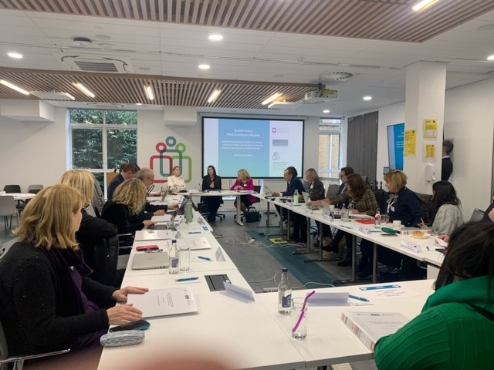

Pictured are members of the three Commissions meeting in IHREC’s offices in Dublin.



Pictured are Commission members and senior staff from across IHREC, ECNI and NIHRC at the second annual meeting of the three full Commissions, in IHREC’s offices in Dublin, November 2022.

### Parliamentary engagement

#### Joint Oireachtas Committee on the Implementation of the Good Friday Agreement

The Chief Commissioners of the three Commissions appeared before the Joint Oireachtas Committee on the Implementation of the Good Friday Agreement on 29 June 2023. The focus of the meeting was the Commissions’ research and policy recommendations concerning the risk of a divergence of rights across the island of Ireland post Brexit. All Oireachtas members received copies of the research and policy reports to coincide with the meeting.

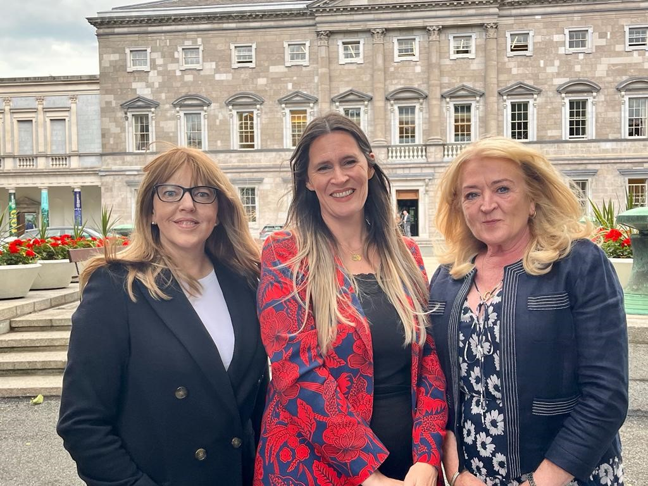

Pictured left to right outside of the Oireachtas are: Alyson Kilpatrick, Chief Commissioner (NIHRC); Sinéad Gibney, Chief Commissioner (IHREC); and Geraldine McGahey, Chief Commissioner (ECNI).

The Chief Commissioners outlined the risk of disparities in protections arising where EU laws that strengthen equality and human rights are introduced in Ireland but are not required to be implemented in Northern Ireland, now that the UK has left the EU. The Chief Commissioners engaged with members of the Oireachtas Committee on key recommendations to mitigate this risk of divergence of rights and strengthen protections post Brexit on the island of Ireland. This included those recommendations made jointly by all three Commissions set out above on pages 9-10.

There was positive feedback from a number of Committee members in relation to the research and policy recommendations and a clear interest amongst members in this work by the Commissions.

### Civil society engagement

#### Seminar ‘Rights at risk of divergence on the island of Ireland: 25 years on from the Belfast (Good Friday) Agreement’.

Coinciding with the 25-year anniversary of the Belfast (Good Friday) Agreement, the Commissions held a seminar on 27 April 2023 in Dublin to launch research and policy recommendations on the impact of Brexit on the Divergence of Rights and Best Practice on the Island of Ireland.

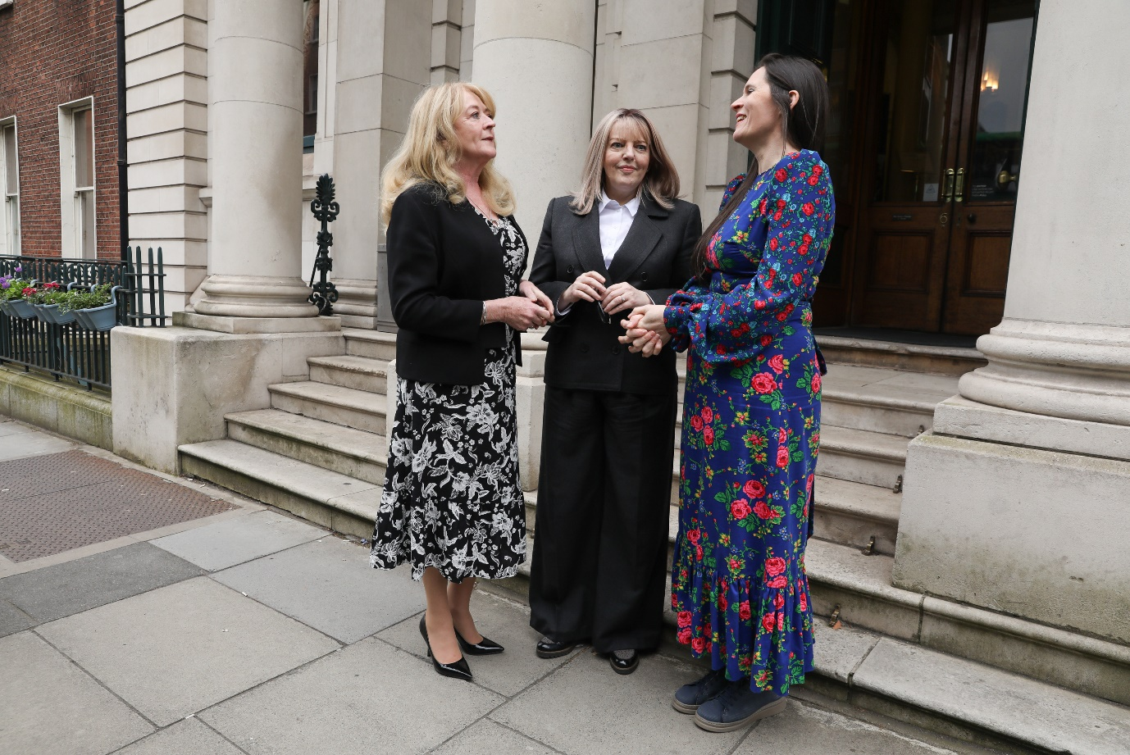

Pictured left to right are Geraldine McGahey, Chief Commissioner (ECNI); Alyson Kilpatrick, Chief Commissioner (NIHRC); and Sinéad Gibney, Chief Commissioner (IHREC), before the Seminar ‘Rights at risk of divergence on the island of Ireland: 25 years on from the Belfast (Good Friday) Agreement’.

Co-author of the independent research report Dr. Eleni Frantziou, Assistant Professor in Public Law and Human Rights at the University of Durham, presented key findings from the research. Roisin Mallon, Director of the Dedicated Mechanism Unit in ECNI, presented the Commissions’ policy recommendations developed on foot of the research findings.

The event then heard responses to these key findings from Professor Christopher McCrudden, Queens University Belfast; Annmarie O’Kane, Centre for Cross Border Studies; and David Fennelly, Free Legal Advice Centres. The responses were supportive of the research report, policy recommendations, and the Commissions’ continued work to uphold the Article 2 commitment.

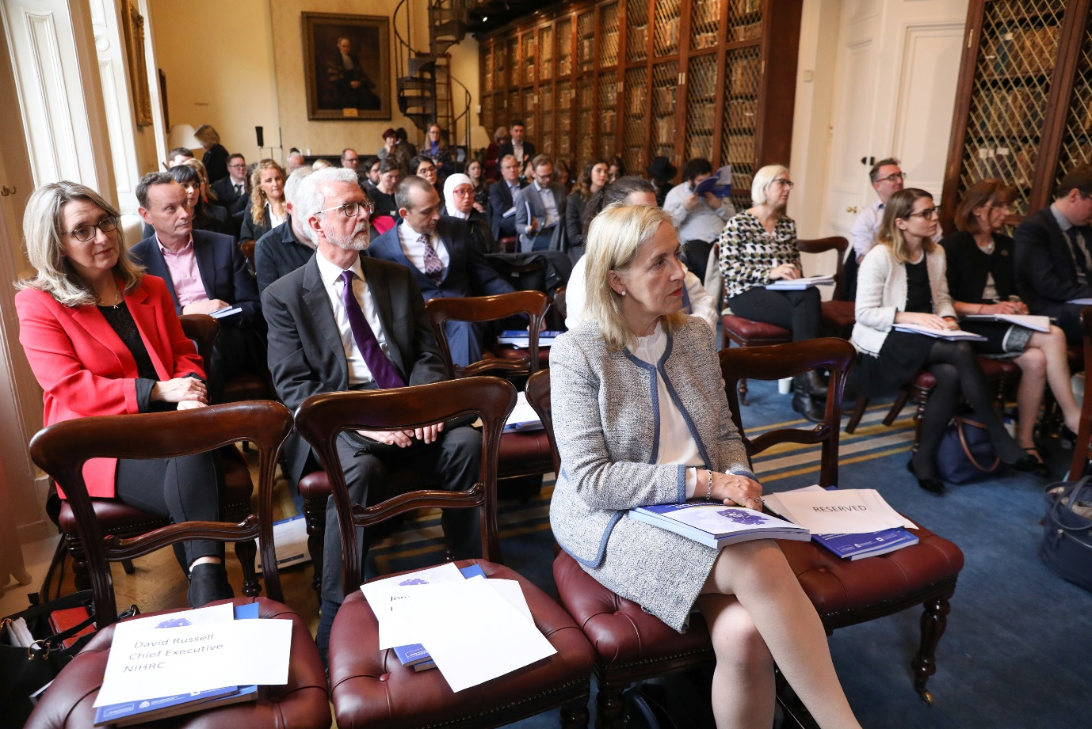

Pictured are participants at the seminar ‘Rights at risk of divergence on the island of Ireland: 25 years on from the Belfast (Good Friday) Agreement’.

The seminar was well attended by key stakeholders working with an island of Ireland perspective, on Brexit-related matters, and in EU affairs. A post event evaluation survey issued by the Commissions found that participants rated the event well, felt the key issues were covered, and agreed they came away from the event with a better understanding of Article 2, the Dedicated Mechanism and issues relating to the divergence of rights across the island of Ireland after Brexit.

### Planned engagement with European Union stakeholders

In February, the Article 2 Working Group agreed to develop plans for joint engagement in Brussels. The plans include holding high-level meetings and hosting a reception aimed at strengthening relationships with relevant stakeholders, including MEPs, with the three Chief Commissioners to represent the Commissions in these engagements.

At the time of writing, meetings are confirmed with senior EU officials and Irish MEPs on 11 October and plans have been confirmed to run the reception that afternoon, kindly hosted by the Office of the Northern Ireland Executive in Brussels.

## Concluding comments

As outlined in this joint report, IHREC, ECNI and NIHRC continue working well together to protect equality and human rights on the island of Ireland after Brexit. The three Commissions have worked consistently over the last year to take forward joint work to raise awareness of, and ensure the UK Government is held to account on, the Article 2 commitment. Such work has included the finalisation of research and policy recommendations concerning the risk of divergence of rights on the island of Ireland. This is a key issue that the Commissions have centred as a focal point for engaging with stakeholders, including civil society from both jurisdictions on the island, and parliamentarians in Dublin and Brussels. Looking ahead, the Commissions remain steadfast in the collective commitment to working together effectively to protect human rights and equality after Brexit for everyone on the island of Ireland.

## Appendix 1: About the Commissions

### Overview

The Irish Human Rights and Equality Commission (IHREC) is Ireland’s National Human Rights Institution and its National Equality Body. It was established on 1 November 2014, as an independent public body under the Irish Human Rights and Equality Commission Act 2014. IHREC is an ‘A status’ National Human Rights Institution as accredited by the United Nations.

Both the Northern Ireland Human Rights Commission (NIHRC) and the Equality Commission for Northern Ireland (ECNI) are non-departmental public bodies established following the Belfast (Good Friday) Agreement and pursuant to the Northern Ireland Act 1998. The NIHRC is a National Human Rights Institution with ‘A status’ accreditation from the United Nations. The Equality Commission is a non-departmental public body with powers and duties that derive from the anti-discrimination legislation in Northern Ireland and the Northern Ireland Act 1998.

The NIHRC and the ECNI are mandated in accordance with Article 2(1) of the Windsor Framework to oversee the UK Government’s commitment on rights and equality in Northern Ireland after EU withdrawal.

The Commissions’ functions for this purpose, set out in Sections 78A-78E of the Northern Ireland Act 1998, are:

* monitoring the implementation of Article 2 (rights of individuals);
* reporting to the Secretary of State for NI and the NI Executive Office on the implementation of Article 2;
* advising the Secretary of State for NI and the NI Executive of legislative and other measures which ought to be taken to implement Article 2;
* advising the NI Assembly (or a committee of the Assembly) whether a Bill is compatible with Article 2;
* promoting understanding and awareness of the importance of Article 2, including undertaking, commissioning or providing financial or other assistance for research and educational activities;
* bringing any appropriate matters of relevance to Article 2 to the attention of the Specialised Committee;
* taking judicial review proceedings in respect of an alleged breach (or potential future breach) of Article 2;
* assisting persons in legal proceedings or proposed proceedings in respect of an alleged breach (or potential future breach) of Article 2; and
* intervening in legal proceedings in so far as they relate to an alleged breach (or potential future breach) of Article 2.

In addition, the IHREC, ECNI, and NIHRC will work together to provide oversight of, and report on, issues which engage Article 2 that have an island of Ireland dimension.

#### NIHRC

The Northern Ireland Human Rights Commission (NIHRC) was established as a result of the Belfast (Good Friday) Agreement 1998. The NIHRC’s governing legislation is the Northern Ireland Act 1998, as amended by the Justice and Security (Northern Ireland) Act 2007 and the European Union (Withdrawal Agreement) Act 2020.

The NIHRC is a National Human Rights Institution with ‘A status’ accreditation from the United Nations. This recognition means that the organisation operates independently in full accordance with the UN General Assembly Resolution 48/134 (the Paris Principles) reporting to UN treaty bodies and exercising speaking rights before the UN Human Rights Council.

The Commission is also a non-departmental public body and receives grant-in-aid from the UK Government through the NI Office. We report to Parliament through the Secretary of State for NI.

The NIHRC also has additional functions, as set out in the Northern Ireland Act 1998, to:

* keep under review the adequacy and effectiveness in NI of law and practice relating to the protection of human rights;
* advise the Secretary of State for NI and the Executive Committee of the NI Assembly of legislative and other measures which ought to be taken to protect human rights;
* advise the NI Assembly whether proposed legislation is compatible with human rights standards;
* promote understanding and awareness of the importance of human rights in NI, for example, by undertaking or commissioning or otherwise assisting research and educational activities;
* give assistance to individuals who apply to it for help in relation to proceedings involving law or practice concerning the protection of human rights;
* bring proceedings involving law or practice concerning the protection of human rights;
* intervene in legal proceedings concerning human rights where it need not be a victim or potential victim of the unlawful act to which the proceedings relate;
* conduct investigations;
* require a person to provide information and documents in their possession, and to give oral evidence, in respect of an investigation;
* enter a specified place of detention in NI, in respect of an investigation; and
* publish its advice and the outcome of its research and investigations.

#### ECNI

The Equality Commission for Northern Ireland (ECNI) is an executive non-departmental public body sponsored by the Executive Office (TEO). The ECNI, established on 1 October 1999 under the Northern Ireland Act 1998, assumed, along with the responsibilities for statutory equality duties and new disability matters, the duties and responsibilities of four former organisations:

* The Commission for Racial Equality for Northern Ireland;
* The Equal Opportunities Commission for Northern Ireland;
* The Fair Employment Commission for Northern Ireland; and
* The Northern Ireland Disability Council.

Since October 1999, additional duties and responsibilities with respect to age, disability, sexual orientation and special educational needs have also been assumed.

During 2009, jointly with the NIHRC, the ECNI was designated as the independent mechanism for NI of the UN Convention on the Rights of Persons with Disabilities (UNCRPD) with the role of promoting, protecting and monitoring the implementation of the Convention.

The main pieces of legislation from which the Commission derives its duties and powers are:

* Sex Discrimination (NI) Order 1976, as amended;
* Disability Discrimination Act 1995, as amended;
* Race Relations (NI) Order 1997, as amended;
* Fair Employment and Treatment (NI) Order 1998, as amended;
* Northern Ireland Act 1998, as amended;
* Equality (Disability, etc.) (NI) Order 2000;
* Employment Equality (Sexual Orientation) Regulations (NI) 2003, as amended;
* Special Educational Needs and Disability (NI) Order 2005, as amended;
* Disability Discrimination (NI) Order 2006;
* Employment Equality (Age) Regulations (NI) 2006, as amended; and
* Equality Act (Sexual Orientation) Regulations (NI) 2006, as amended.

#### IHREC

The Irish Human Rights and Equality Commission (IHREC) was established on 1 November 2014, as an independent public body under the Irish Human Rights and Equality Commission Act 2014. IHREC is Ireland’s independent National Human Rights Institution and its National Equality Body. Since 2020, it is also Ireland’s Independent National Rapporteur on the Trafficking of Human Beings.

IHREC Members are appointed by President Michael D. Higgins, following a resolution by both Houses of the Oireachtas. IHREC operates independently of Government, with its institutional independence guaranteed in its establishing legislation, which provides for accountability of the Commission for its statutory functions to the Oireachtas.

The overall statutory functions of IHREC provided for in section 10 of the legislation are:

* to protect and promote human rights and equality;
* to encourage the development of a culture of respect for human rights, equality, and intercultural understanding in the State;
* to promote understanding and awareness of the importance of human rights and equality in the State;
* to encourage good practice in intercultural relations, to promote tolerance and acceptance of diversity in the State and respect for the freedom and dignity of each person; and
* to work towards the elimination of human rights abuses, discrimination and prohibited conduct.

In undertaking its mandate, IHREC is explicitly tasked with contributing to the development of a society in which:

* there is respect for, and protection of, each person’s human rights;
* there is respect for the dignity and worth of each person;
* a person’s ability to achieve his or her potential is not limited by prejudice, discrimination, neglect or prohibited conduct;
* each person has a fair and equal opportunity to participate in the economic, political, social or cultural life of the State; and
* there is mutual respect between persons, including classes of persons, based on a shared understanding of the value of diversity within society and on a shared respect for equality and human rights.

For further information and guidance, please contact:

Equality Commission for Northern Ireland
Equality House, 7-9 Shaftesbury Square, Belfast, BT2 7DP Telephone: + 44 (0)28 9050 0600
Email: DMU@equalityni.org
Web: www.equalityni.org/brexit

The Irish Human Rights and Equality Commission
Coimisiún na hÉireann um Chearta an Duine agus Comhionannas 16-22 Sráid na Faiche, Baile Átha Cliath 7, D07 CR20
16-22 Green Street, Dublin 7, D07 CR20
Íosghlao/Lo-call 1890 245 245
Guthán/Phone + 353 (0) 1 858 3000
Ríomhphost/Email info@ihrec.ie
Idirlíon/Web www.ihrec.ie

Northern Ireland Human Rights Commission
4th Floor Alfred House, 19-21 Alfred Street, Belfast, BT2 8ED Telephone: + 44 (0)28 9024 3987
Email: info@nihrc.org
Web: www.nihrc.org/brexit

1. Agreement on the Withdrawal of the UK of Great Britain and NI from the EU and the European Atomic Energy Community 2020 (UK-EU Withdrawal Agreement).
2. Article 2(1), Windsor Framework (formerly Ireland/Northern Ireland Protocol) to the UK-EU Withdrawal Agreement.
3. The ECNI and the NIHRC published a joint working paper on the scope of Article 2(1) of the Windsor Framework in December 2022. See Equality Commission for Northern Ireland and Northern Ireland Human Rights Commission, [Working Paper: The Scope of Article 2(1) of the Ireland/ Northern Ireland Protocol](https://www.equalityni.org/ECNI/media/ECNI/Publications/Delivering%20Equality/DMU/NIHRC-ECNI-Scope-of-Protocol-Working-Paper-December-2022.pdf), (ECNI and NIHRC, December 2022).
4. Equality Commission for Northern Ireland, Irish Human Rights and Equality Commission, and Northern Ireland Human Rights Commission, [Ireland/Northern Ireland Protocol of the European Union (EU) Withdrawal Agreement, Article 2: island of Ireland dimension. Memorandum of Understanding](https://nihrc.org/uploads/MoU-IHREC.NIHRC.ECNI-on-Art-2-all-island-scrutiny-Signed.pdf). March 2021.
5. [The Belfast Agreement: An Agreement Reached at the Multi-Party Talks on Northern Ireland](https://assets.publishing.service.gov.uk/media/619500728fa8f5037d67b678/The_Belfast_Agreement_An_Agreement_Reached_at_the_Multi-Party_Talks_on_Northern_Ireland.pdf) (NIO, 1998), page 18.
6. Equality Commission for Northern Ireland and Northern Ireland Human Rights Commission, [Working Paper: The Scope of Article 2(1) of the Ireland/ Northern Ireland Protocol](https://www.equalityni.org/ECNI/media/ECNI/Publications/Delivering%20Equality/DMU/NIHRC-ECNI-Scope-of-Protocol-Working-Paper-December-2022.pdf), (ECNI and NIHRC, 2022)
7. Article 13, Windsor Framework (formerly Ireland/Northern Ireland Protocol) to the UK-EU Withdrawal Agreement
8. Sarah Craig, Anurag Deb, Eleni Frantziou, Alexander Horne, Colin Murray, Clare Rice and Jane Rooney, [European Union developments in Equality and Human Rights: The Impact of Brexit on the divergence of rights and best practice on the island of Ireland](https://www.equalityni.org/ECNI/media/ECNI/Publications/Corporate/Misc/Temp/EU-EqualityHumanRights-BrexitImpactAC.pdf), (ECNI, NIHRC, IHREC 2022)
9. Directive 2019/1158/EU ‘Directive of the European Parliament and Council on work-life balance for parents and carers’, 20 June 2019.
10. Directive 2019/882/EU, ‘Directive of the European Parliament and Council on the accessibility requirements for products and services’, 17 April 2019.
11. European Commission (2020), [LGBTIQ Equality Strategy 2020-2025](https://commission.europa.eu/system/files/2020-11/lgbtiq_strategy_2020-2025_en.pdf).
12. Sarah Craig, Anurag Deb, Eleni Frantziou, Alexander Horne, Colin Murray, Clare Rice and Jane Rooney, [European Union developments in Equality and Human Rights: The Impact of Brexit on the divergence of rights and best practice on the island of Ireland](https://www.equalityni.org/ECNI/media/ECNI/Publications/Corporate/Misc/Temp/EU-EqualityHumanRights-BrexitImpactAC.pdf), (ECNI, NIHRC, IHREC 2022), pages 60-79.
13. Case C-16/19, Szpital Kliniczny im. dra J. Babińskiego Samodzielny Publiczny Zakład Opieki Zdrowotnej w Krakowie, [EU:C:2021:64](https://curia.europa.eu/juris/document/document.jsf?text=&docid=236963&pageIndex=0&doclang=en&mode=lst&dir=&occ=first&part=1&cid=114623).
14. Joined Cases C‑804/18 and C‑341/19, IX v WABE eV and MH Müller Handels GmbH v MJ, [EU:C:2021:594](https://curia.europa.eu/juris/document/document.jsf?text=&docid=245416&pageIndex=0&doclang=en&mode=req&dir=&occ=first&part=1&cid=114150).
15. Case C-30/19 Diskrimineringsombudsmannen v Braathens Regional Aviation AB, [EU:C:2021:269](https://curia.europa.eu/juris/document/document.jsf?docid=239882&mode=req&pageIndex=1&dir=&occ=first&part=1&text=&doclang=EN&cid=114409).
16. Sarah Craig, Anurag Deb, Eleni Frantziou, Alexander Horne, Colin Murray, Clare Rice and Jane Rooney, [European Union developments in Equality and Human Rights: The Impact of Brexit on the divergence of rights and best practice on the island of Ireland](https://www.equalityni.org/ECNI/media/ECNI/Publications/Corporate/Misc/Temp/EU-EqualityHumanRights-BrexitImpactAC.pdf), (ECNI, NIHRC, IHREC 2022).
17. Equality Commission for Northern Ireland, Northern Ireland Human Rights Commission and Irish Human Rights and Equality Commission, [Policy Recommendations: European Union developments in Equality and Human Rights: The Impact of Brexit on the divergence of rights and best practice on the island of Ireland](https://www.equalityni.org/ECNI/media/ECNI/Publications/Delivering%20Equality/DMU/Brexit-DivergenceRecommendations.pdf), (ECNI, NIHRC and IHREC, 2023), pages 37-41, 58-61.
18. Ibid.
19. Equality Commission for Northern Ireland, [Public Awareness Survey of equality and human rights protections in Northern Ireland after Brexit.](https://www.equalityni.org/Footer-Links/News/Delivering-Equality/Attitudes-to-equality-and-human-rights-protections)
20. There were 2,136 responses. These responses were audited and weighted, and the results are representative of the Northern Ireland population. This resulted in 1,247 full responses which were recorded and used for analysis